NETWORK FUNDAMENTALS AND BUILDING NETWORKS

ETHERNET STANDARD AND SPECIFICATION

TASK1: Draw a simple diagram showing the pin layout of an RJ-45 connector and label the color codes for the T568A and T568B Ethernet wiring standards.
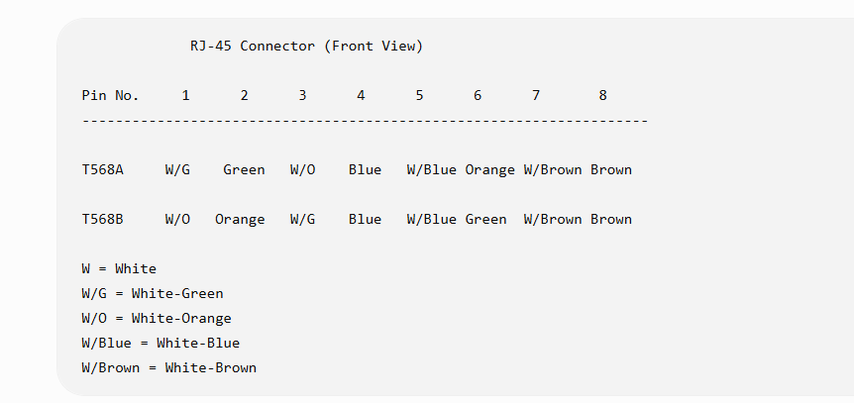

TASK2: Create a table comparing the key specifications of Ethernet standards 10BASE-T, 100BASE-TX, and 1000BASE-T, including speed, cable type, maximum cable length, and connector type.
Ethernet Standard | Speed | Cable Type | Maximum Cable Length | Connector Type
10BASE-T | 10 Mbps | Cat3/Cat5 | 100 meters | RJ-45
100BASE-TX | 100 Mbps | Cat5 | 100 meters | RJ-45
1000BASE-T | 1000 Mbps (1 Gbps) | Cat5e/Cat6 | 100 meters | RJ-45

TASK3: Given a scenario where you need to connect two laptops directly using Ethernet, explain which cable (straight-through or crossover) you would use and why.<br><br><em><strong>Hint:</strong> Think about how transmit and receive pairs are wired in each cable type.</em>
To connect two laptops directly, I would use a Crossover Cable.
Reason
A crossover cable swaps the transmit and receive wires, allowing both laptops to communicate directly without using a switch or router.

TASK4: List three real-world devices in your home or college that use Ethernet connections, and for each, specify the likely Ethernet standard (e.g., 100BASE-TX, 1000BASE-T) they support.
Device | Ethernet Standard
Desktop Computer (College Lab) | 1000BASE-T
Wi-Fi Router | 1000BASE-T
Network Printer | 100BASE-TX

